Computer Networks Lab 03
Name: Hafsa Salman
Roll no. 22K-5161

Question no. 01
Server:
import socket
import threading
import os

HOST = '127.0.0.1'
PORT = 9999

def handle_client(client_socket, addr):
print(f"Connected to {addr}")

while True:
try:
data = client_socket.recv(1024).decode()
if not data:
break

if data == "FILE_TRANSFER":
receive_file(client_socket)
else:
print(f"Client: {data}")
message = input("Server: ")
client_socket.sendall(message.encode())

except Exception as e:
print(f"Error: {e}")
break

client_socket.close()

def receive_file(client_socket):
filename = client_socket.recv(1024).decode()
file_size = int(client_socket.recv(1024).decode())

with open(filename, "wb") as file:
received = 0
while received < file_size:
data = client_socket.recv(1024)
file.write(data)
received += len(data)

print(f"File {filename} received successfully.")

def start_server():
server_socket = socket.socket(socket.AF_INET, socket.SOCK_STREAM)
server_socket.bind((HOST, PORT))
server_socket.listen(1)
print(f"Server listening on {HOST}:{PORT}...")

while True:
client_socket, addr = server_socket.accept()
client_thread = threading.Thread(target=handle_client, args=(client_socket, addr))
client_thread.start()

start_server()

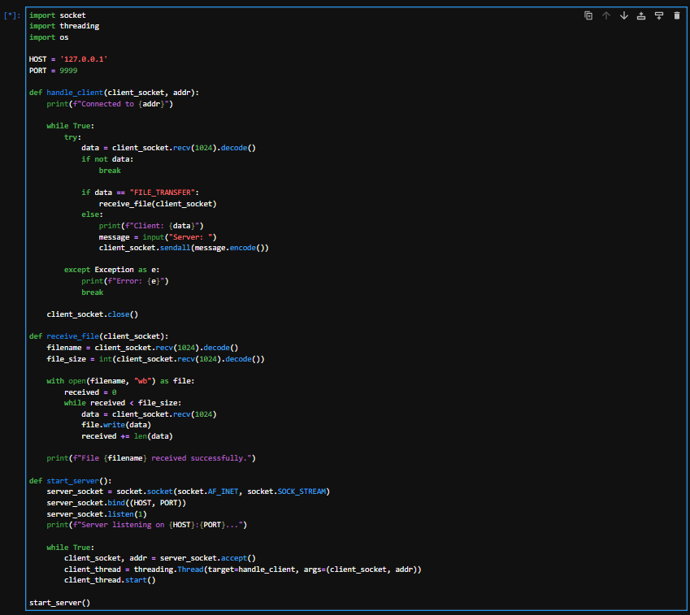

Client:
import socket
import os

HOST = '127.0.0.1'
PORT = 9999

def send_file(client_socket):
filename = input("Enter the file path: ")

if not os.path.exists(filename):
print("File does not exist!")
return

client_socket.sendall("FILE_TRANSFER".encode())

client_socket.sendall(os.path.basename(filename).encode())
client_socket.recv(1024)

file_size = os.path.getsize(filename)
client_socket.sendall(str(file_size).encode())

with open(filename, "rb") as file:
while chunk := file.read(1024):
client_socket.sendall(chunk)

print(f"File {filename} sent successfully.")

def chat_client():
client_socket = socket.socket(socket.AF_INET, socket.SOCK_STREAM)
client_socket.connect((HOST, PORT))

print("Connected to the server. Type 'exit' to quit, 'sendfile' to send a file.")

while True:
message = input("Client: ")

if message.lower() == "exit":
break
elif message.lower() == "sendfile":
send_file(client_socket)
else:
client_socket.sendall(message.encode())
response = client_socket.recv(1024).decode()
print(f"Server: {response}")

client_socket.close()

chat_client()

